Fluid Mechanics Course essay  
Student name: Nguyen Xuan Binh Student number: 887799

**Application of Reynolds number in fluid flows**

**A) Introduction**

Reynolds number (Symbol Re) is a dimensionless quantity in fluids mechanics, proposed by Osborne Reynolds in the 19th century. Physically, Reynolds number is the ratio of inertial forces to viscous forces in a fluid flow. Reynolds number is crucial to understanding the flow types, where they are either laminar, turbulent, or transitional types. The magnitude of Reynolds number is directly linked to which flow type the flow would be.

* Laminar flow: fluids flow in smooth paths in parallel layers, with no or very little disruptions between these layers (Re < 2000)
* Turbulent flow: fluids flow in irregular fluctuations, where the fluid layers are heavily mixed (Re > 4000)
* Transitional flow: the combination of the two flow types: transitioning from laminar flow type to turbulent flow type, or vice versa (2000< Re < 4000)

Reynolds number formula is defined as:  (1), where the variables (SI units) are  
ρ: fluid density (kg/m3); V: [flow speed](https://en.wikipedia.org/wiki/Flow_speed) (m/s); L: characteristic length (m)  
μ: [dynamic viscosity](https://en.wikipedia.org/wiki/Dynamic_viscosity) (kg/m·s); ν: [kinematic viscosity](https://en.wikipedia.org/wiki/Kinematic_viscosity) (m2/s)

**B) Entrance length of fluids in a pipe flow**

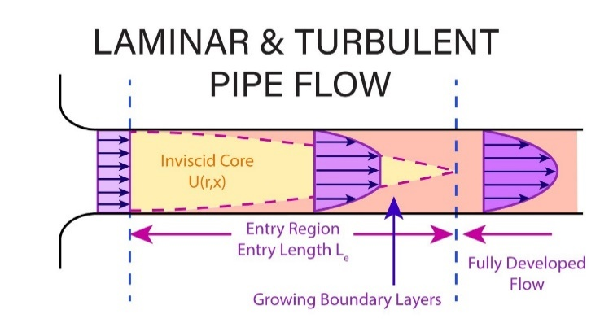A fluid flow in a pipe is divided into two phases: developing phase (entrance phase) and fully developed phase (Figure 1). During the entrance phase, the flow’s boundary layer does not fully form and its velocity profile varies along the longitudinal distance. In a fully developed zone, the inviscid core from the entrance phase vanishes as the boundary layer grows further. Thus, the flow’s velocity profile ceases to change as the fluid continues to flow (Pimpun Tongpun et al.). The entrance length depends on various factors such as the fluid type, pipe material, entrance corner, roughness and cross-sectional area (Pimpun Tongpun et al.). For both turbulent flow and laminar flow, the entrance length for pipe flow is a function of Reynolds number (Bengtson, 2011), where Le is entrance length and D is pipe diameter.

Figure 1: Fluid flow in a circular pipe

Laminar flow:  Turbulent flow: 

The entrance length is important to pipe design. For example, models should be placed in uniform flow in the test section of wind tunnels, which requires knowledge of entrance length. Calculation of fluid properties is more accurate in a uniform flow than in a developing flow.

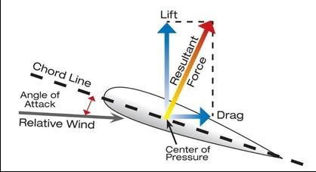**C) Low Reynolds number in airfoil design**

Airfoil is a cross-sectional shape of structures that utilizes fluid flows to generate significant lift force, such as wings of planes, blades, or turbines (Figure 2). Airfoil design should aim to maximize lift force while minimizing drag force. Currently, low Reynolds number airfoil designs have been demonstrated to produce more lift force and delay the occurrence of flow separation than high Reynolds number design (Yang Zhang, 2020). It is found in a study that in the low Reynolds number range (Re < 60,000), some models of airfoils such as SD7003 and Ishii has high-performance with a relatively high lift-to-drag ratio (Anyoji M, 2019). On the other hand, low Reynolds number is also beneficial for testing. The formula of Reynolds number depends on fluid velocity and characteristic length; to test airfoil models, one should achieve realistic conditions and as a result, fluid velocity and the length of the airfoil model must be smaller than those of the prototype. Assume there is dynamic similarity between the prototype and the model, Reynolds number of fluids flow should be small in real conditions.

Figure 2 Airfoil diagram

**D) Exercises**

Problem 1   
At [20°C, what is the maximum flow rate of water to remain as a laminar flow in a pipe having a diameter of 1cm? (Check properties of water in Figure 3)](https://www.google.com/url?sa=t&rct=j&q=&esrc=s&source=web&cd=&ved=2ahUKEwiwooGvmtHzAhWK-ioKHQ60Aq4QFnoECBIQAQ&url=https%3A%2F%2Fwww.rapidtables.com%2Fconvert%2Ftemperature%2Fcelsius-to-fahrenheit.html&usg=AOvVaw3C37GjZaCqZyB7w7jiXG2J)

Figure 3: Properties of water   
at different temperature

We know that fluid flows remain laminar if Re < 2000. Therefore, at 20°C:



(maximum flow rate)

**Problem 2:** (Cimbala, n.d.)

The full-size wing prototype has chord length, cp, density, viscosity, air speed Vp, angle of attack α and generates a lift force, Lp. Suppose there is dynamic similarity between the model and prototype, find the formula for lift force and air velocity acting on the prototype in Figure 4

Figure 4: Airfoil wing of airplanes, model and prototype

Lift force is a function that depends on 5 variables:, where angle of attack α is dimensionless. Applying Pi-theorem in reducing relevant variables: k = 5, r = 3 (M, L, T) =>  
Number of Pi terms: k - r = 2, we have the following dimensionless function:

 or 

There is dynamic similarity between the model and prototype (Note: )  (Air velocity acting on the prototype) => (Lift force of the prototype)

**E) References**

[1] Anyoji M, Hamada D. High-performance airfoil with low reynolds-number dependence on

aerodynamic characteristics. Fluid Mech Res Int J. 2019;3(2):76‒80. DOI: 10.15406/fmrij.2019.03.00055

[2] Bengtson, H., 2011. Use the Pipe Flow Reynolds Number for Turbulent Flow to find the

Entrance Length for Fully Developed Flow. [Online]. Available at: https://www.brighthubengineering.com/hydraulics-civil-engineering/55543-pipe-flow-calculations-1-the-entrance-length-for-fully-developed-flow/ [Accessed 17 10 2021].

[3] Cimbala, J. M., n.d. *me.psu.edu.* [Online]. Available at: <https://www.me.psu.edu/cimbala/>

[Accessed 17 10 2021].

[4] P. Tongpun, E. Bumrungthaichaichan, S. Wattananusorn (2014) Investigation of entrance

length in circular and noncircular conduits by computational fluid dynamics simulation.

Songklanakarin Journal of Science and Technology. 36(4): 471–475.

[5] Yang Zhang, Z. Z. K. W. X. L., 2020. Aerodynamic Characteristics of Different Airfoils

under Varied Turbulence Intensities at Low Reynolds Numbers. 2 March, p. 19.